St Andrews Website

Contents

Document Control 1

About this document 1

Website architecture 2

Deployment Model 2

Development Model 3

Security Model 4

Administration 5

Google App Engine 5

Google Analytics 9

Google Webmaster tools 9

Development 10

System requirements 10

Workstation set-up 10

Updates and publication 10

Source structure 11

# Document Control

|  |  |
| --- | --- |
| Title | St Andrews Website |
| Status | Draft |
| Last Modified |  |
| Version |  |
| Author(s) | Antony Cartwright |

# About this document

This document contains a description of the current St Andrews website, the tools available to manage and monitor the site and the tools and processes for updating the site.

# Website architecture

The site is a Java Web Application which can be run either on a single workstation or deployed to a public server. With the exception of the domain name provider, the entire infrastructure used to host and manage the site is provided by Google free of charge.

## Deployment Model

The Deployment Model shows the components that are used to present and manage the running web site application.

Analysis tools

Deployed application stack

Go Daddy – standrewshalifax.org.uk

Google Analytics

Google Apps (Mail and Sites)

Google Webmaster Tools

St Andrews Halifax Web App

Google App Engine

### Go Daddy

Go Daddy is the organisation that resolves standrewshalifax.org.uk to a specific address depending on usage. Both email and web traffic are routed to Google Apps

### Google Apps

Google Apps is a suite of productivity applications which we use to host both the @standrewshalifax.org.uk email accounts (Google Mail) and link the registered web site domain [www.standrewshalifax.ork.uk](http://www.standrewshalifax.ork.uk) to the site on Google App Engine (Google Sites).

### St Andrews Halifax Web App

The website code including the site structure built from Struts Tiles and Java Server Pages (JSPs), the content in HTML. Source code is compiled on a local workstation before either running in a local machine or being deployed to a hosting provider.

### Google App Engine

Google App Engine is an application hosting service which supports our application and many other variants of a web application.

### Google Analytics

Google Analytics provide traffic tracking tools which show how the website is being used, from where and how often.

### Google Webmaster Tools

Google Web Master Tools are a collection of site quality and optimisation tools.

## Development Model

The Development Model shows the components involved in updating and publishing the site.

Development workstation

Remote services

St Andrews Halifax Web Site Source

Java

Maven

Google App Engine

Google Code

Subversion

Google App Engine (SDK)

### Java

Java is the core technology used to build the site. There only 5 Java files in the source code so Java skills are not likely to be required for day-to-day updates.

### Maven

Maven is a build automation tool which runs from the command line (e.g. “Command Prompt” on Windows or “Terminal” on a Mac or Linux)

### Struts

Struts is a web framework which provides libraries to structure the site and create re-usable components. The most noticeable place this is used is for Struts Tiles which are used to maintain the site top level page structure by including a standard header, footer and left navigation.

### Subversion (“SVN”)

Subversion is a version control system designed for source code. Changes are committed to a central repository so many people can collaborate on a single application. Each file has it’s full history of changes tracked.

### Google Code

Google Code is a free version control provider who includes support for subversion. As a condition of providing a free service source code managed in Google Code must be available for other’s to share.

## Security Model

Protection against malicious modifications to the site is through username / password authentication. Accounts are currently shared so no user level auditing is possible. The web application source code is publicly available so it is important that no sensitive information is checked into the source code repository. Passwords must be maintained separately.

There are several accounts which are applicable to one or more service. The structure below shows which services are authenticated using which accounts:

* Go Daddy account (standrewshalifax)
  + Go Daddy - <http://www.godaddy.com/>
* Google account ([standrewshalifax@gmail.com](mailto:standrewshalifax@gmail.com))
  + Google Mail - <https://mail.google.com/>
  + Google App Engine - <http://appengine.google.com/>
  + Google Analytics - <http://www.google.co.uk/analytics/>
  + Google Webmaster tools - <https://www.google.com/webmasters/tools/>
  + Google Code - <http://code.google.com/> (separate SVN password)
* Google Apps administration account (standrewshalifax)
  + Google Apps - <https://www.google.com/a/standrewshalifax.org.uk/>
* Google Mail contact email account ([contact@standrewshalifax.org.uk](mailto:contact@standrewshalifax.org.uk))
  + Google Mail - <http://webmail.standrewshalifax.org.uk/>

# Administration

Website administration in this context is limited to switching between website versions, viewing analytics data and viewing website site performance.

Google Apps includes a plethora of features not covered in this document, the most useful of which is the ability to create new accounts so for email addresses. To investigate Google Apps start with an overview like this: <http://www.youtube.com/watch?v=kJT3pagjd8s>

The Go Daddy domain name service can be used to re-point some or all of the services associated with the standrewshalifax.org.uk domain to alternate providers. This task is not covered in this document. There is help on the Go Daddy site but generally caution is advised as domain administration assumes a reasonable amount of background knowledge.

## Google App Engine

Google app engine is used to host the St Andrews Halifax Java Web Application. With the same account it is possible to host other web applications built using other technologies. A Software Development Kit (“SDK”) can be downloaded onto a workstation to test the deployment of applications prior to use on the public internet.

Google App Engine provides supporting services such as authentication, storage and caching. At present the St Andrews Halifax site only uses email. The Payer Vine and Visitors Form both use the email service to send a message to the Google account to [contact@standrewshalifax.org.uk](mailto:contact@standrewshalifax.org.uk).

Google App Engine is accessed using the Google Account: [standrewshalifax@gmail.com](mailto:standrewshalifax@gmail.com)

To access Google App Engine visit this URL: <http://appengine.google.com/>

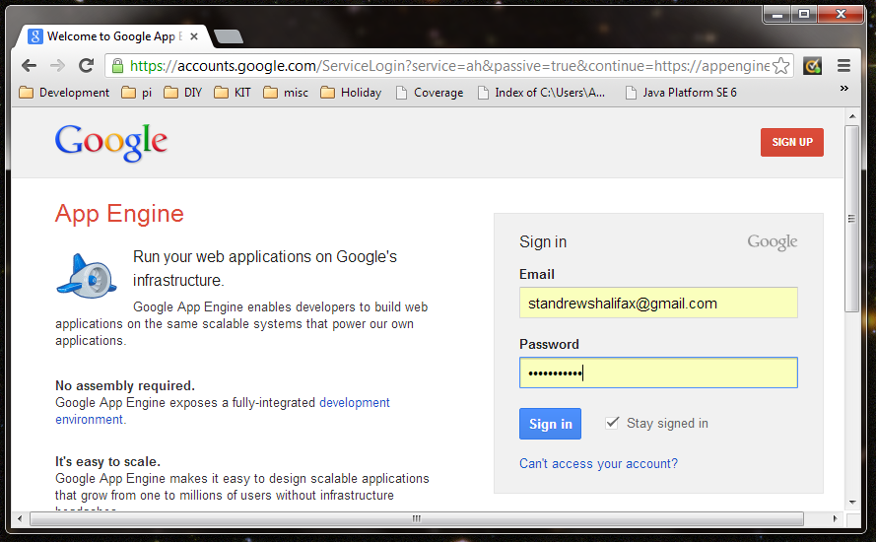

Sign in to see a list of applications:

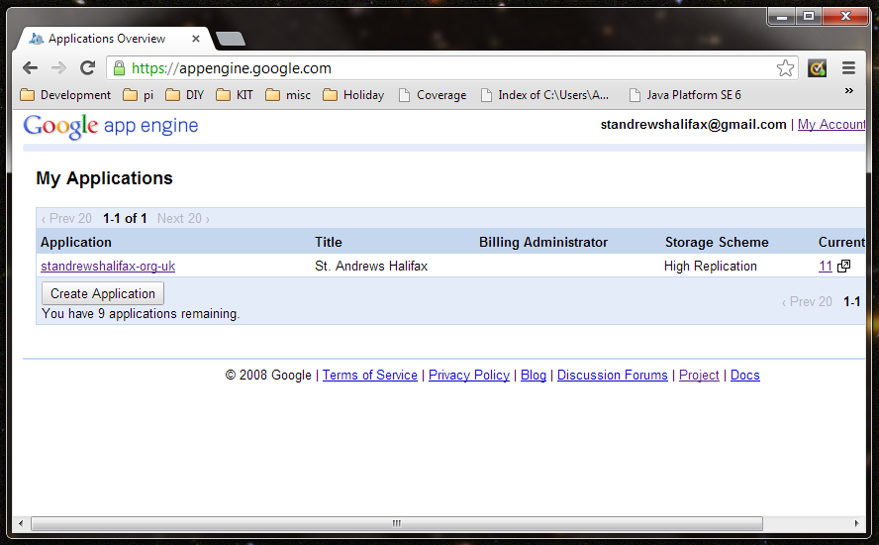

Click [standrewshalifax-org-uk](https://appengine.google.com/dashboard?&app_id=s~standrewshalifax-org-uk) to view the application dashboard:

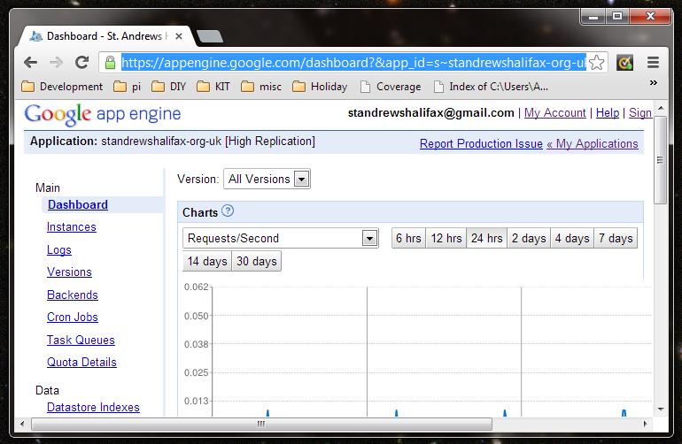

Click Versions to see which versions have been uploaded to the site:

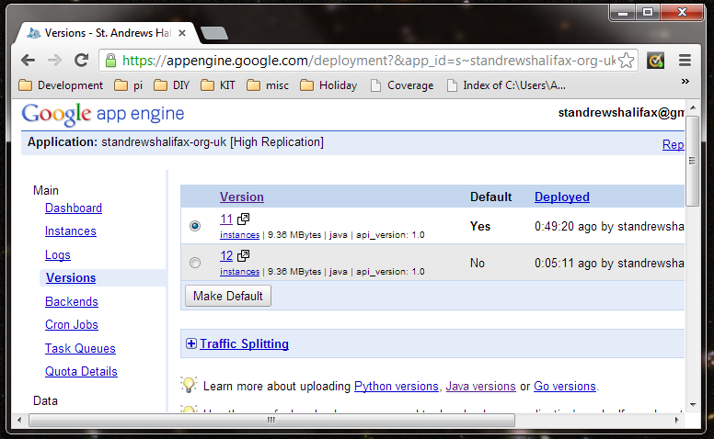

A specific version of the application can be viewed by clicking on the version number. Note the link in the browser contains the version number. In this case for version 12 we have: <http://12.standrewshalifax-org-uk.appspot.com/>

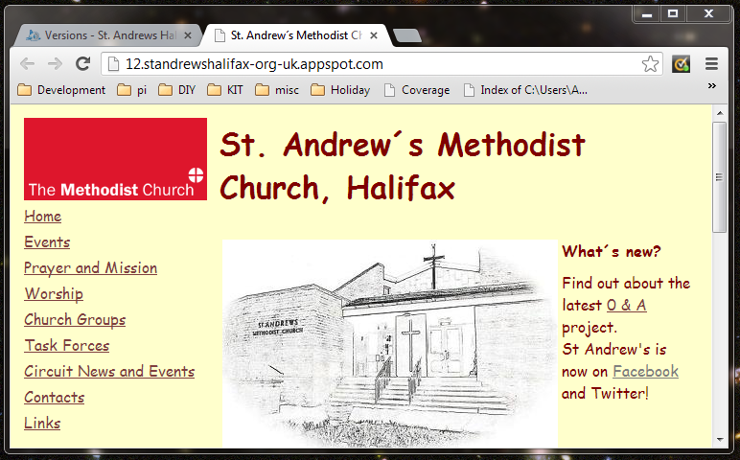

(Just after a new version has been uploaded it may take a few seconds for the site to load)

A different version can be enabled by selecting a version and clicking “Make Default”:

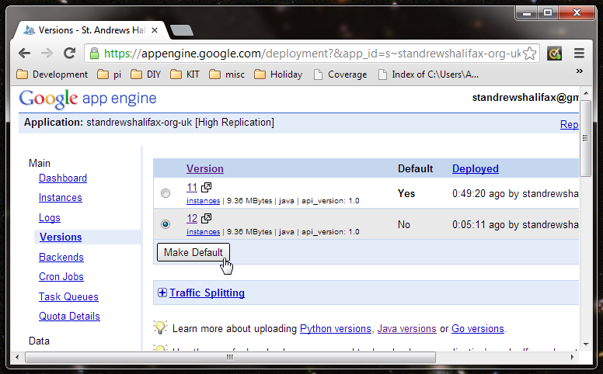

The default version is publicly available at <http://standrewshalifax-org-uk.appspot.com/> as well as the canonical URL of <http://www.standrewshalifax.org.uk/>. The .appspot.com version will be available even if the canonical URL of the site is not available. Any links given to external sites should only use the canonical URL to ensure consistency. To help search engines only to index the canonical URLs the site includes a robots.txt file reference to a sitemap at standrewshalifax-org-uk.

<http://standrewshalifax-org-uk.appspot.com/robots.txt> :

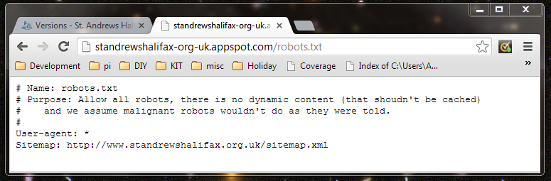

Click Quota Details to see how much of the daily usage quota has been consumed:

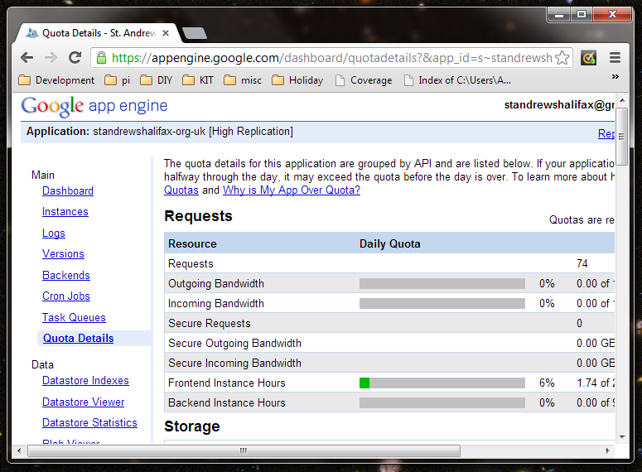

If the quota reached 100% in any day an additional allowance shall need to be purchased. Looking at the usage of St Andrews to date this is unlikely. In the event of a sudden spike in usage Google Analytics can be used to learn more about the source of the traffic.

## Google Analytics

## Google Webmaster tools

# Development

## System requirements

To complete the instructions below an internet connected computer with a Windows, Mac or Linux operating system installed. Each individual software package will have its own specific hardware and software requirements. A modestly priced PC purchased in the last 3 years with a domestic broadband connection should be sufficient.

The instructions below were created using Windows 7 and have not been tested on other operating systems.

## Workstation set-up

### Install Java & check

### Install Google app engine SDK

### Install SVN client

### Install Maven & check

### Check out code

### Run in local SDK

### Check with browser

## Updates and publication

### Update your workspace

### Check version number on deployed version

### If the current number is in use, move to next number

### Make changes

### Build using mvn clean install

### Deploy to local version and check

### Deploy to remove version and check

### Switch default version to the new version

### Commit changes

# Source structure